We use a few feature extraction strategies listed below: We consider a 10-level decomposition of the learned wavelet (DeSpaWN) for all methods. Each level has a different number of coefficients, and they represent the same time window (with different sampling rates).

Grids2:. Implemented in notebook "Extract_features_DeSpaWN_Grids2", by function "extract_DeSpaWN_grids". Each level is separated into five regions, called grids. Each decomposition level has five grids. Each grid [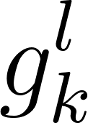](https://latex-staging.easygenerator.com/eqneditor/editor.php?latex=g_k%5El#0) comprises the average value of the coefficients that make up a time window [](https://www.codecogs.com/eqnedit.php?latex=%5Cfrac%7BT%7D%7B5%7D#0) of the level [](https://www.codecogs.com/eqnedit.php?latex=l#0), where T is the total period of the input temporal sample of the Learned Wavelet. Each page of the feature tensor [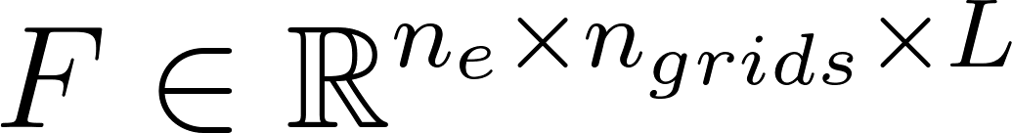](https://www.codecogs.com/eqnedit.php?latex=F%20%5Cin%20%5Cmathbb%7BR%7D%5E%7Bn_%7Be%7D%20%5Ctimes%20n_%7Bgrids%7D%20%5Ctimes%20L#0) is given by an [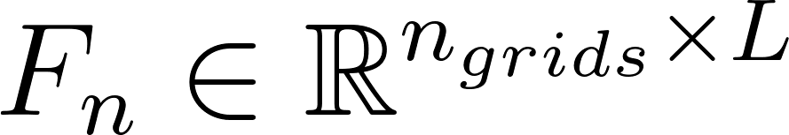](https://www.codecogs.com/eqnedit.php?latex=F_%7Bn%7D%20%5Cin%20%5Cmathbb%7BR%7D%5E%7Bn_%7Bgrids%7D%20%5Ctimes%20L%7D#0) matrix, where [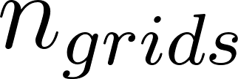](https://latex-staging.easygenerator.com/eqneditor/editor.php?latex=n_%7Bgrids%7D#0) is the number of grids and L is the number of decomposition levels.

For grids2, [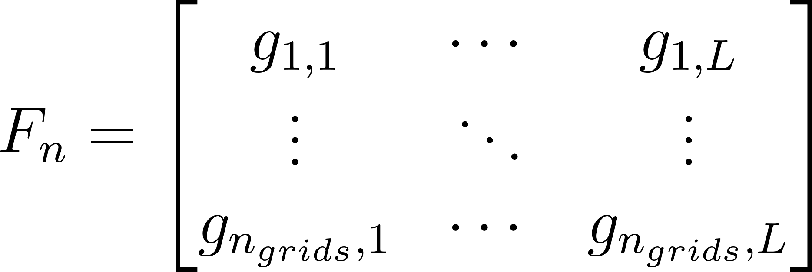](https://www.codecogs.com/eqnedit.php?latex=F_%7Bn%7D%20%3D%20%5Cbegin%7Bbmatrix%7D%20g_%7B1%2C1%7D%20%26%20%5Ccdots%20%26%20g_%7B1%2CL%7D%20%5C%5C%5C%5C%20%5Cvdots%20%20%20%26%20%5Cddots%20%26%20%5Cvdots%20%5C%5C%5C%5C%20g_%7Bn_%7Bgrids%7D%2C1%7D%20%26%20%5Ccdots%20%26%20g_%7Bn_%7Bgrids%7D%2CL%7D%20%5Cend%7Bbmatrix%7D#0), where [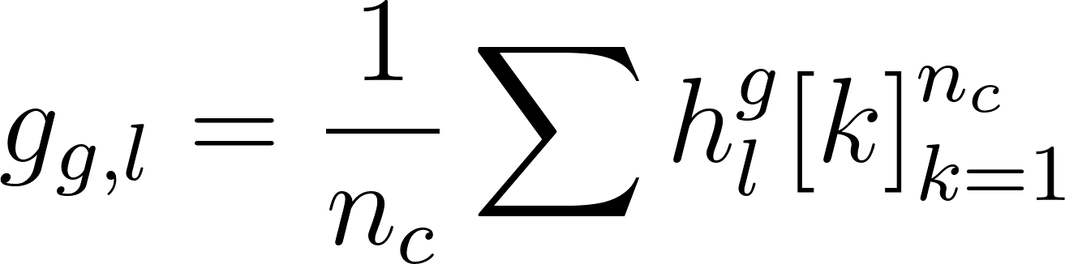](https://www.codecogs.com/eqnedit.php?latex=g_%7B%7Bg%7D%2Cl%7D%20%3D%20%5Cfrac%7B1%7D%7Bn_c%7D%20%5Csum%7Bh_l%5Eg%20%5Bk%5D%7D_%7Bk%3D1%7D%5E%7Bn_c%7D#0)

Grids3:. Implemented in notebook "Extract_features_DeSpaWN_Grids3", by function "extract_DeSpaWN_grids3". Each level is separated into five regions, called grids. Each decomposition level has five grids. Each grid [](https://latex-staging.easygenerator.com/eqneditor/editor.php?latex=g_k%5El#0) comprises the average value of the coefficients that make up a time window [](https://www.codecogs.com/eqnedit.php?latex=%5Cfrac%7BT%7D%7B5%7D#0) of the level [](https://www.codecogs.com/eqnedit.php?latex=l#0), where T is the total period of the input temporal sample of the Learned Wavelet. Each page of the feature tensor [](https://www.codecogs.com/eqnedit.php?latex=F%20%5Cin%20%5Cmathbb%7BR%7D%5E%7Bn_%7Be%7D%20%5Ctimes%20n_%7Bgrids%7D%20%5Ctimes%20L#0) is given by an [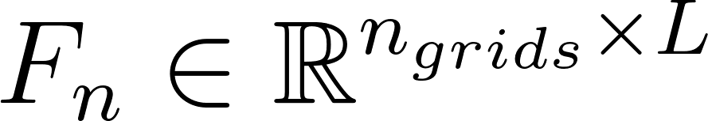](https://latex-staging.easygenerator.com/eqneditor/editor.php?latex=F_%7Bn%7D%20%5Cin%20%5Cmathbb%7BR%7D%5E%7Bn_%7Bgrids%7D%20%5Ctimes%20L%7D#0) matrix, where [](https://latex-staging.easygenerator.com/eqneditor/editor.php?latex=n_%7Bgrids%7D#0) is the number of grids and L is the number of decomposition levels.

For grids3, [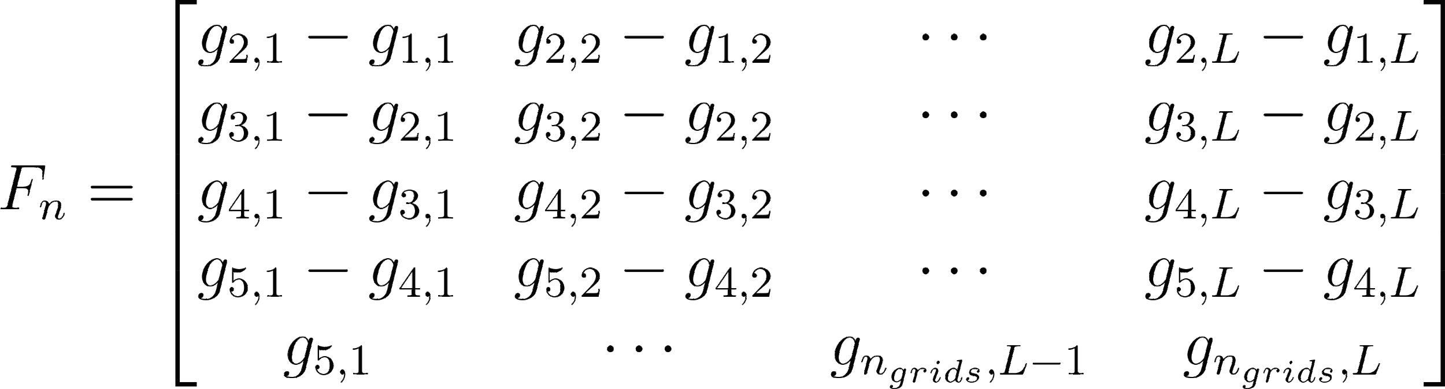](https://latex-staging.easygenerator.com/eqneditor/editor.php?latex=F_%7Bn%7D%20%3D%20%5Cbegin%7Bbmatrix%7D%20g_%7B2%2C1%7D%20-%20g_%7B1%2C1%7D%20%26%20g_%7B2%2C2%7D%20-%20g_%7B1%2C2%7D%20%26%20%5Ccdots%20%26%20g_%7B2%2CL%7D%20-%20g_%7B1%2CL%7D%20%5C%5C%5C%5C%20g_%7B3%2C1%7D%20-%20g_%7B2%2C1%7D%20%26%20g_%7B3%2C2%7D%20-%20g_%7B2%2C2%7D%20%26%20%5Ccdots%20%26%20g_%7B3%2CL%7D%20-%20g_%7B2%2CL%7D%20%5C%5C%5C%5C%20g_%7B4%2C1%7D%20-%20g_%7B3%2C1%7D%20%26%20g_%7B4%2C2%7D%20-%20g_%7B3%2C2%7D%20%26%20%5Ccdots%20%26%20g_%7B4%2CL%7D%20-%20g_%7B3%2CL%7D%20%5C%5C%5C%5C%20g_%7B5%2C1%7D%20-%20g_%7B4%2C1%7D%20%26%20g_%7B5%2C2%7D%20-%20g_%7B4%2C2%7D%20%26%20%5Ccdots%20%26%20g_%7B5%2CL%7D%20-%20g_%7B4%2CL%7D%20%5C%5C%5C%5C%20g_%7B5%2C1%7D%20%26%20%5Ccdots%20%26%20g_%7Bn_%7Bgrids%7D%2CL-1%7D%20%26%20g_%7Bn_%7Bgrids%7D%2CL%7D%20%5Cend%7Bbmatrix%7D#0) , where [](https://www.codecogs.com/eqnedit.php?latex=g_%7B%7Bg%7D%2Cl%7D%20%3D%20%5Cfrac%7B1%7D%7Bn_c%7D%20%5Csum%7Bh_l%5Eg%20%5Bk%5D%7D_%7Bk%3D1%7D%5E%7Bn_c%7D#0)

Grids4:. Implemented in notebook "Extract_features_DeSpaWN_Grids4", by function "extract_DeSpaWN_grids4". Each level is separated into five regions, called grids. Each decomposition level has five grids. Each grid [](https://latex-staging.easygenerator.com/eqneditor/editor.php?latex=g_k%5El#0) comprises the average value of the coefficients that make up a time window [](https://www.codecogs.com/eqnedit.php?latex=%5Cfrac%7BT%7D%7B5%7D#0) of the level [](https://www.codecogs.com/eqnedit.php?latex=l#0), where T is the total period of the input temporal sample of the Learned Wavelet. Each page of the feature tensor [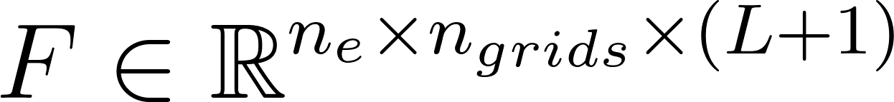](https://www.codecogs.com/eqnedit.php?latex=F%20%5Cin%20%5Cmathbb%7BR%7D%5E%7Bn_%7Be%7D%20%5Ctimes%20n_%7Bgrids%7D%20%5Ctimes%20(L%2B1)#0) is given by an [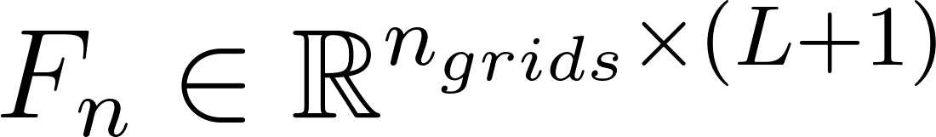](https://latex-staging.easygenerator.com/eqneditor/editor.php?latex=F_%7Bn%7D%20%5Cin%20%5Cmathbb%7BR%7D%5E%7Bn_%7Bgrids%7D%20%5Ctimes%20(L%2B1)%7D#0) matrix, where [](https://latex-staging.easygenerator.com/eqneditor/editor.php?latex=n_%7Bgrids%7D#0) is the number of grids and L is the number of decomposition levels.

For grids4, [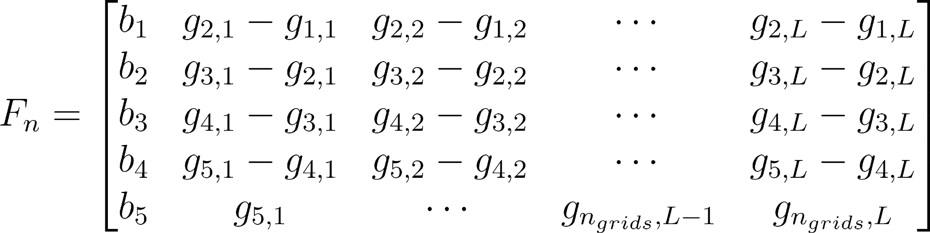](https://latex-staging.easygenerator.com/eqneditor/editor.php?latex=F_%7Bn%7D%20%3D%20%5Cbegin%7Bbmatrix%7D%20b_1%20%26%20g_%7B2%2C1%7D%20-%20g_%7B1%2C1%7D%20%26%20g_%7B2%2C2%7D%20-%20g_%7B1%2C2%7D%20%26%20%5Ccdots%20%26%20g_%7B2%2CL%7D%20-%20g_%7B1%2CL%7D%5C%5C%5C%5C%20b_2%20%26%20g_%7B3%2C1%7D%20-%20g_%7B2%2C1%7D%20%26%20g_%7B3%2C2%7D%20-%20g_%7B2%2C2%7D%20%26%20%5Ccdots%20%26%20g_%7B3%2CL%7D%20-%20g_%7B2%2CL%7D%20%20%5C%5C%5C%5C%20b_3%20%26%20g_%7B4%2C1%7D%20-%20g_%7B3%2C1%7D%20%26%20g_%7B4%2C2%7D%20-%20g_%7B3%2C2%7D%20%26%20%5Ccdots%20%26%20g_%7B4%2CL%7D%20-%20g_%7B3%2CL%7D%20%5C%5C%5C%5C%20b_4%20%26%20g_%7B5%2C1%7D%20-%20g_%7B4%2C1%7D%20%26%20g_%7B5%2C2%7D%20-%20g_%7B4%2C2%7D%20%26%20%5Ccdots%20%26%20g_%7B5%2CL%7D%20-%20g_%7B4%2CL%7D%20%5C%5C%5C%5C%20b_5%20%26%20g_%7B5%2C1%7D%20%26%20%5Ccdots%20%26%20g_%7Bn_%7Bgrids%7D%2CL-1%7D%20%26%20g_%7Bn_%7Bgrids%7D%2CL%7D%20%5Cend%7Bbmatrix%7D#0) , where , $$a_0$$ are the approximation coefficients of the wavelet transform, $$n_e$$ is the number of elements in $$a_0$$, $$h_l^g$$ is the set of detailing coefficients of the level $$l $$ and in the grid $$g$$.  are the approximation coefficients of the wavelet transform, 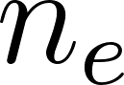 is the number of elements in , 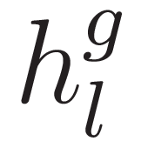is the set of detailing coefficients of the level  and in the grid .